**HOW TO MAKE A BUCKET IN MINECRAFT**

In this article, you will come to know how to make a bucket in Minecraft. Minecraft is a famous 3-D sandbox video game and it is a brick-based game. If you want to know more articles based on Minecraft, you can access via this link <https://www.gamingqna.online/how-to-make-fireworks-in-minecraft/>.

To create a bucket, you need to collect 3 iron ingots and we need to place 2 iron ingots on both sides of the first row, and 1 ingot in the last row at the middle, then your bucket is ready. After completing this task move bucket to the inventory.

**Required items to make a bucket:**

* Three iron ingots
* Crafting Table
* Furnace

We need a stone pickaxe to mine the iron core.

Here is the process for making a bucket in Minecraft.

**Steps to make a BUCKET:**

**Step1:** First we need to find iron ore and need to pick at least three iron ore samples. We can find the iron ore by its brown speck’s characteristic. Iron ore is used as a material for making buckets.

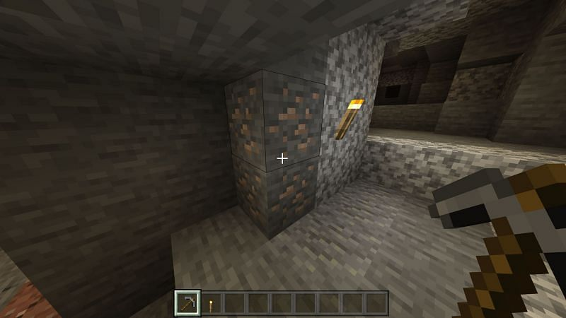

**Step2:** After finding the ore we need to smelt the iron ore into small iron ingots. We can make this smelting process by using a furnace.

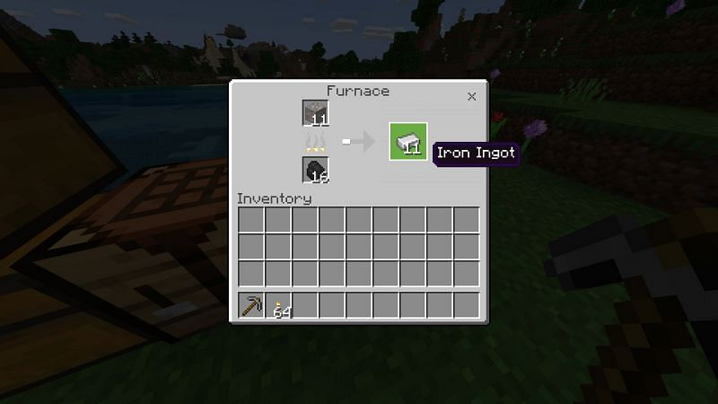

**Step3:** If we are done with the smelting process, then we need to arrange them on the crafting table, placing 2 iron ingots on both sides of the first row, and 1 ingot in the last row at the middle of the 3 x 3 crafting grid. As shown below in the picture

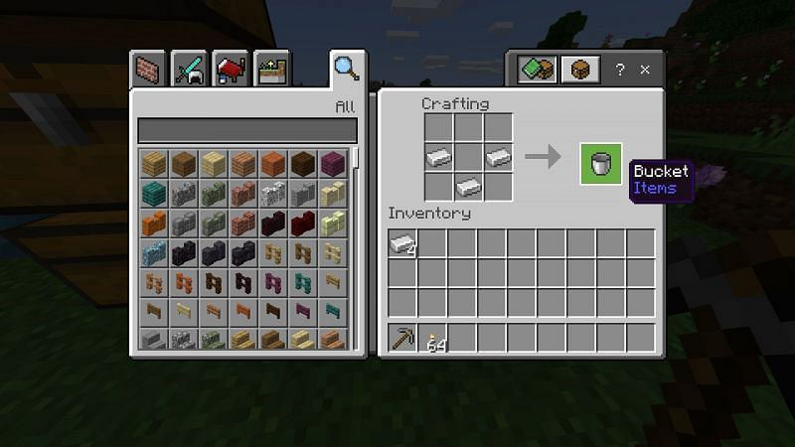

Once we crafted the buckets, we need to move new items to the inventory. By following the above steps, we are done with making a bucket in Minecraft. Buckets can carry any liquids within them.

**USES OF BUCKET IN MINECRAFT:**

In Minecraft, buckets are used to carry water, lava, milk, powder snow, live fish, axolotls. To use a bucket in Minecraft, simply just right-click on whatever you would like to fill the bucket with. A common thing you may run into is transporting water for a farm or simply to have on hand. With two water sources, you can infinitely fill your buckets with water. This can be useful if you do not want to travel to the nearby ocean or river anytime you need water.

The pages on the **water bucket** and **Lava bucket** describe uses when transporting lava and water. Buckets can only be used to pick up water and lava **source** blocks, not the flowing blocks. To empty a full bucket containing water or lava, place the bucket on the source block. That will empty the bucket.

In Minecraft Lava buckets are also used as weapons. These may destroy the Mob’s drops or even they may lead to the player’s death.

Buckets can also be used to Milk cows or Mushrooms. A bucket of milk can be used to craft certain food or to remove all status effects. Water buckets can be used to manually return regular zombies into Drowned to farm them.

**ASSUME THAT WE USED A BUCKET FOR WATER OR LAVA OR MILK:**

**1.** **Water**: Let four blocks contain water, later we remove another block beside those blocks. Now, we observe that water flows into that block too and maintains the water level equal. Right-click with the bucket in your hand to fill. Water is the one liquid you can place down without causing harm.

**2. Lava:** Taking **lava** in place of water. If we dig another block beside those blocks, we can observe that the lava will start flowing into that block. Rarely, you may find a lava pool spawning above the surface. Right-click with the bucket in your hand to fill. Take care not to fall in while retrieving. Also, take care not to place the bucket of lava in such a way as to accidentally burn down your house (and kill off your character).

**3. Milk:** Right-click on a cow. It is the one liquid that is not placeable in the unmodified version of the game. You can use it to make a cake or drink it to rid yourself of either negative or positive potion effects (depends on the potion).

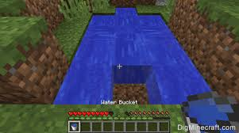

**CONCLUSION:**

Minecraft is a famous 3-D visualizing game that can be supported in any operating system. I hope that this article helped you a lot in the creation of the bucket in Minecraft and the uses of the bucket. Be careful while you are placing the iron ingots in 3 x 3 grids. Play Minecraft with your friends and have fun. We also keep on posting about a lot of different games, have a look at them. If you found this article useful do share it with your friends and comment on how you found out about this article.

**Article by,**

Noone Harshan

9550949044